**Sales Dataset Analysis-Advanced Excel Project Insights**

Objective:

To analyze sales data to identify trends, understand sales performance to make better decision for future sales.

Scope:

The analysis covers the sales data from last 4 years, it covers the total sales, sales by category, sales trend overtime, high-performing products and sales channels.

Audience:

This analysis will be helpful for sales management team and decision makers who requires insights to guide their strategies and actions.

Data Collection:

Dataset is about product sales both online and offline and sales through different channels.

Data Cleaning:

Cleaned the dataset using Power Query. Removed Blank Rows, Duplicate Rows and Splitter Columns.

Techniques Used:

Analysed the data set and generated the required business insight and created the pivot tables, Various chats for visualisation, and used interactive filters.

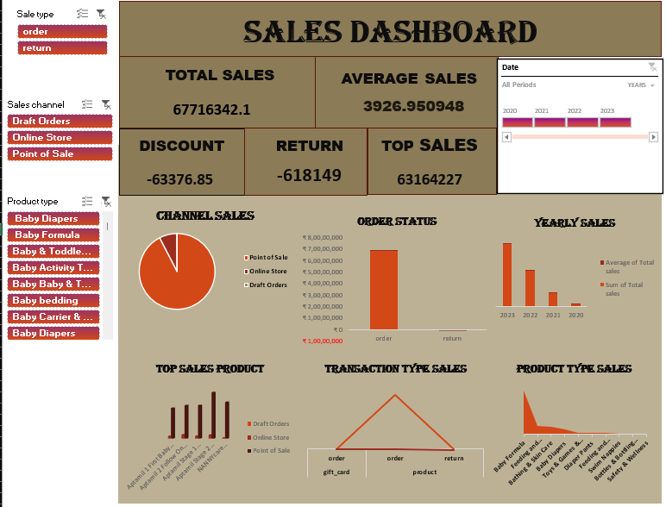

Findings:

* Top selling Products are Baby Formula followed by feeding and weaning.
* Seasonal Peak is in September
* Gradually sales increased year by year.
* Comparing Online and Offline sale, Sales trend increased in Offline.

Conclusion:

Our analysis shows that Baby Formula and feeding &weaning products have more sales in September. This trend demonstrates steady annual growth, highlighting opportunities for making growth in future by increasing more offers and discount in the sales.